Bridgepoint Parts Catalog

Section XXXVI: Water Softeners Page 1

PALA11

Head – Manual Water Softener
AC39

PALA12

Head – with Timer

Automatic Water Softener
AC40 & AC40B
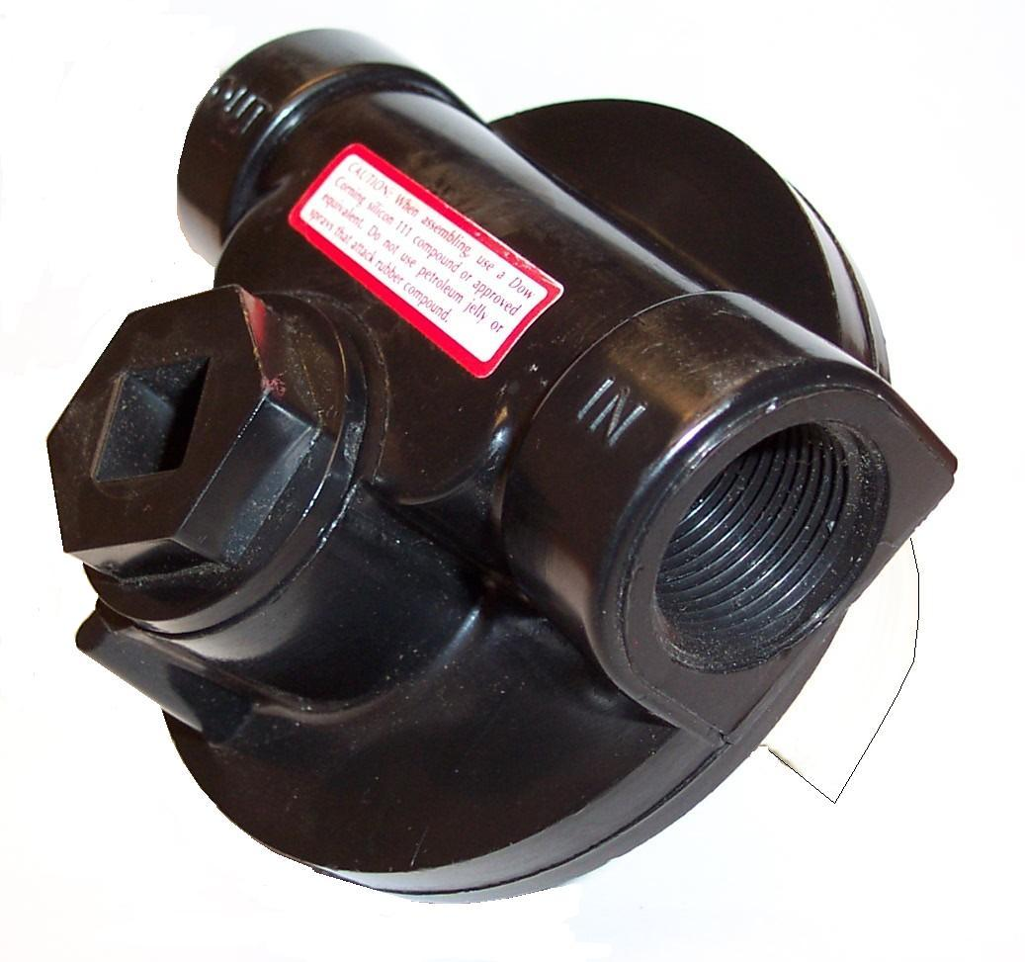

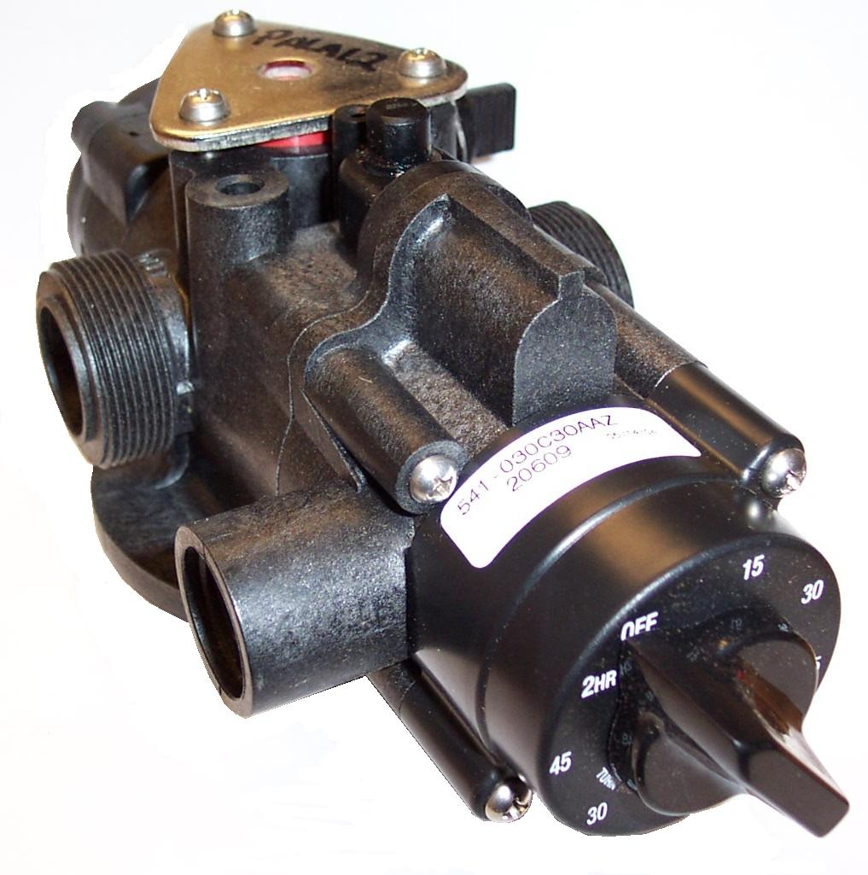

PALA13

Kit Adapter Fittings
Automatic Softener Head

AC40 & AC40B

PALA10

Plug Manual Softener Head
Salt fill port

AC39

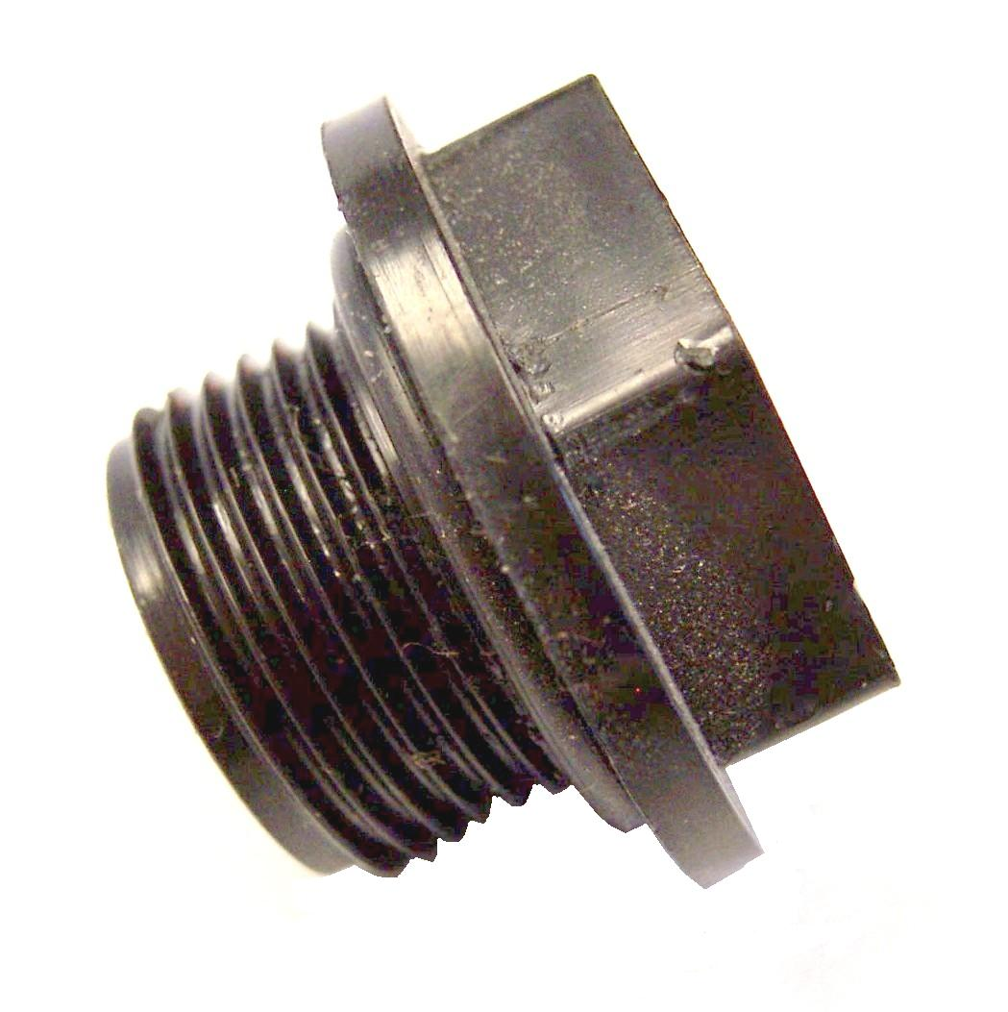

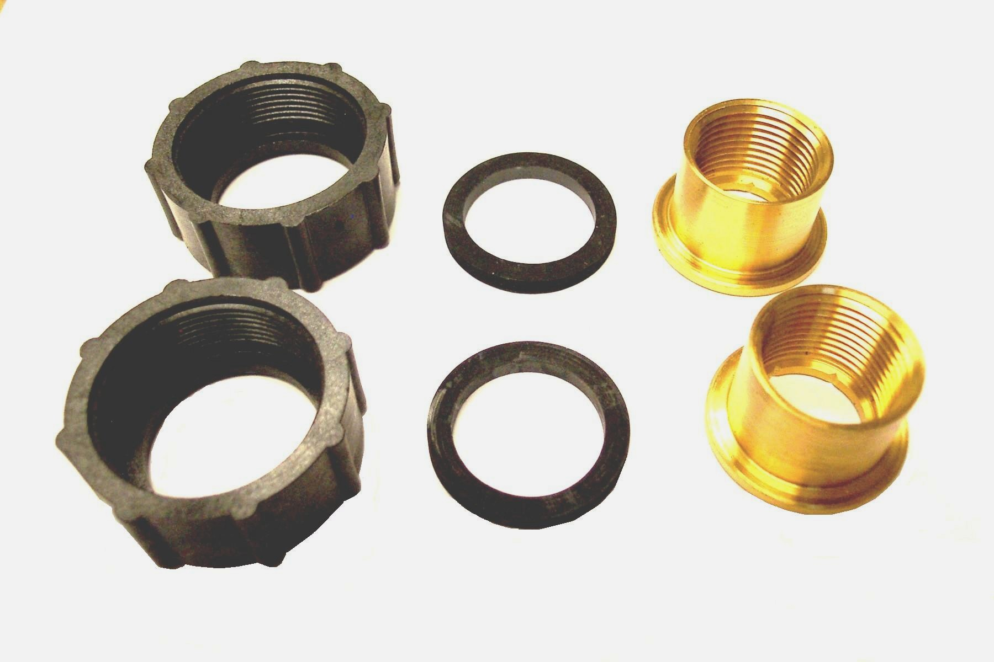

PALA14

Valve Brine Tank

AC40 & AC40B

AC39A
Stand – Water Softener

AC39 & AC40

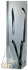

PALA15

Plug Brine Fitting
Automatic Softener Head

AC40 & AC40B
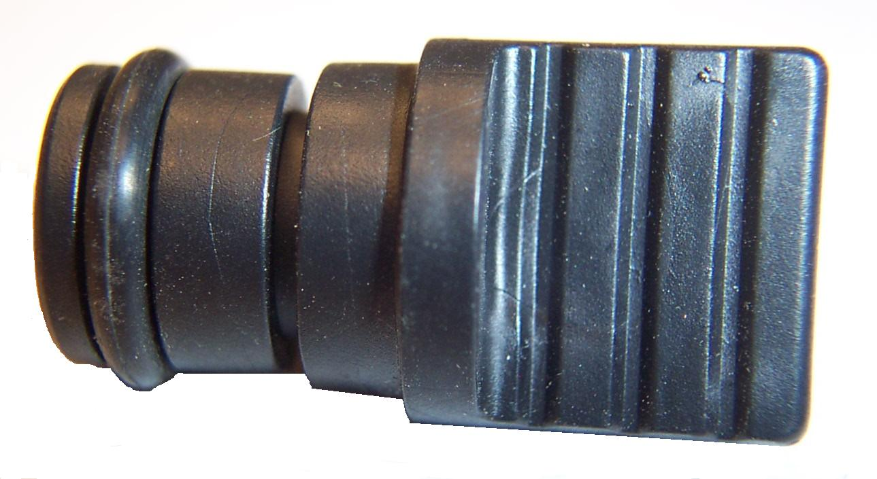

PALA16

Clip Brine Plug Retainer
Automatic Softener Head

AC40 & AC40B

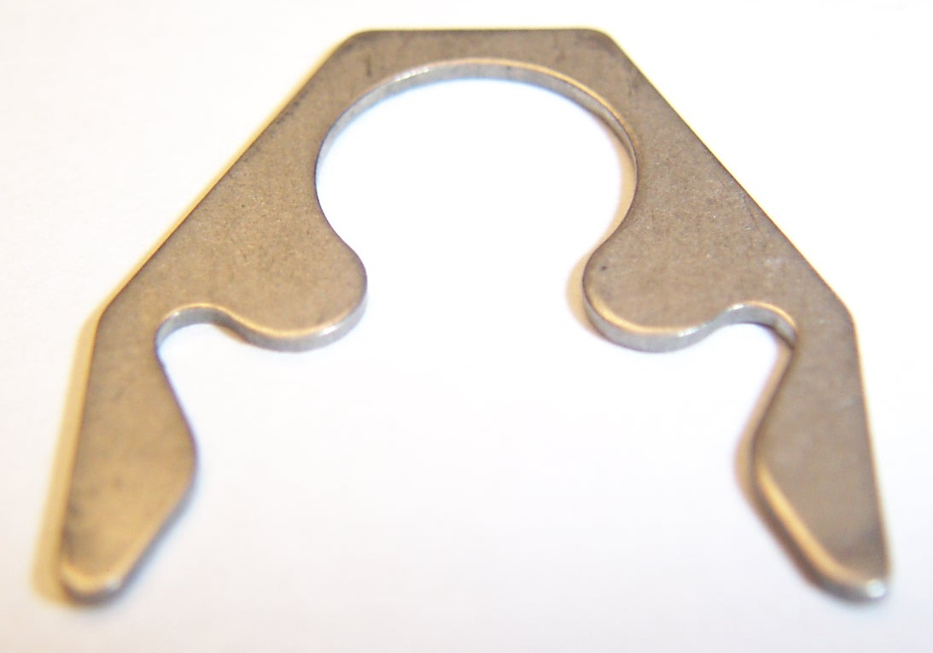

PALA20

Brine Tank Assembly – AC40
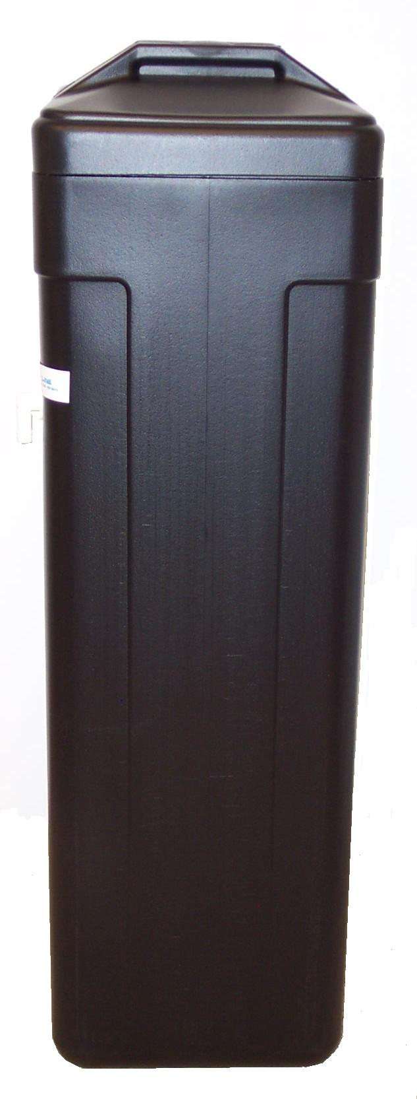

PALA250-1

Brine Adapter with Elbow

Automatic Softener Head

AC40 & AC40B
